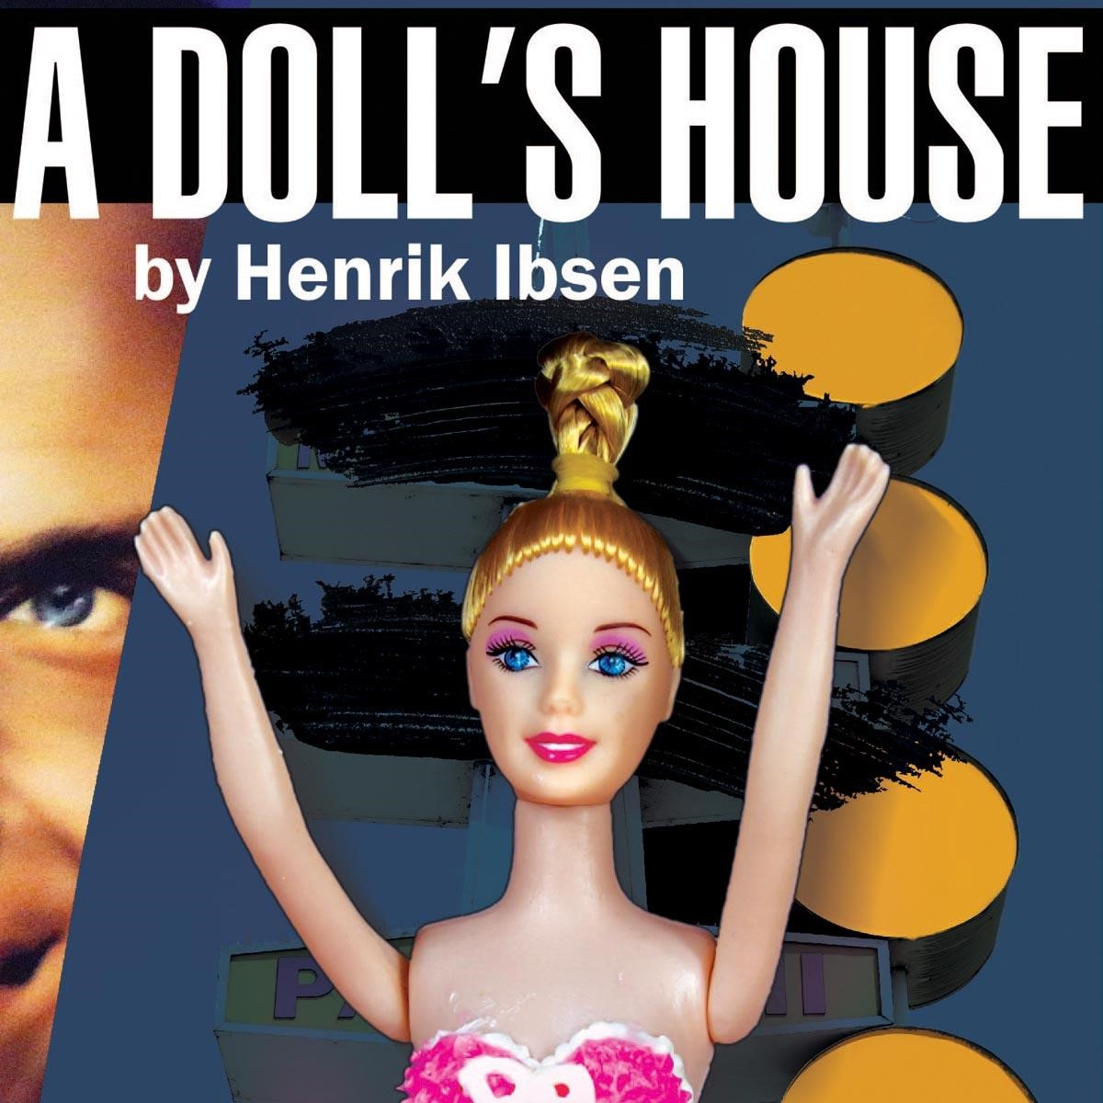

*A Doll’s House*

Study Guide

This Study Guide was written by Kate Jones-Waddell and edited by Kacey Roye. It contains selected excerpts from public domain.

***Show Runs November 3rd – November 26th, 2017***

# Table of Contents

|  |  |
| --- | --- |
| **PAGE** | **SECTION** |
| 3 | About A Doll’s House |
| 4 | *A Doll’s House* Cast & Production Staff |
| 5 | Synopsis |
| 7 | About the Playwright |
| 8 | Facts About *A Doll’s House* |
| 9 | Analysis of Major Themes |
| 10 | Vocabulary |
| 11 | Pre-Play Activities |
| 13 | Post-Play Activities |
| 14 | Theatre Etiquette |
| 15 | Free Student Programs at The Classic Theatre |

**MISSION:** The Classic Theatre creates excellent theatre that is relevant, diverse, entertaining, and transformative.

**VISION:** We seek to achieve our mission by creating connections and conversations through compelling classic works.

# Classic Theatre Staff

|  |  |
| --- | --- |
| Kelly Roush | Executive Director |
| Diane Malone & Allan Ross | Co-Artistic Directors |
| Grace Kanayan | Director of Development |
| Kacey Roye | Director of Education |
| Florence Bunten | Box Office Manager |
| Olivia Tober | Bookkeeper |
| Rita Duggan, Chelsea Steele | House Manager |

## About *A Doll’s House*

“To be nobody-but-yourself in a world which is doing its best, day and night, to make you like everybody else means to fight the hardest battle which any human being can fight; and never stop fighting.”

-E. E. Cummings

The last words of Henrik Ibsen were: “To the contrary!” It is a fitting epigraph to his body of work, which stands starkly at odds with the dominant social conventions of his day. Born in 1828 in Skien, Norway, Ibsen grew up in affluence but his father’s lack of business acumen thrust the family into poverty when he was eight. At 15, he quit school and worked as an apothecary’s apprentice, painting and writing poetry in his spare time. His first play, Catiline, was published in 1850 – and was a commercial flop. A lucky break at 23 landed him a gig as a writer and manager for the Norwegian Theatre in Bergen, where he would hone his craft. A few years later, accusations of theater mismanagement would exile him to Italy and then Germany, where he continued to write world-changing work. When he eventually returned to Norway in 1891, he was hailed as a hero, but suffered a stroke and was unable to write in his declining years. He died on May 23, 1906 in Oslo. Ibsen was not one to shy away from weighty subject matter, tackling death, disease, distrust of religion, marital strife, and sexual indiscretion in works such as Ghosts and Hedda Gabler. Whatever else his plays were, they were controversial. A Doll’s House was no different, with its Copenhagen world premiere in 1879 hailed as a “powerful work of art [about] a shocking truth,” while its German premiere in 1880 was staged with an alternate ending because the show was deemed too upsetting for polite society. Ibsen, of course, would take issue with our modern-day relegation of A Doll’s House to mere feminist text. As one popular bumper sticker notes, women’s rights are human rights; from Ibsen’s standpoint, he wrote not a feminist play, but a humanist one. In it, he examines basic human questions about individual freedom, social justice, moral autonomy, and the right to selfgovernance. In Love and Responsibility, Karol Wojtyla -- better known as Pope John Paul II – writes: “No one else can want for me. No one can substitute his act of will for mine. It does sometimes happen that someone very much wants me to want what he wants. This is the moment when the impassable frontier between him and me, which is drawn by free will, becomes most obvious ... I am, and I must be, independent in my actions. All human relationships are posited on this fact.” For Ibsen, this “fact” is the foundation of A Doll’s House and the sum and summit of all human wisdom: Who is truly free? What does it mean to be free? And how do we become so?

-Donna Provencher, M.A.

# *A Doll’s House* Cast & Production Staff

**Cast of Characters**

|  |  |
| --- | --- |
| Kacey Roye | Nora Helmer |
| Nick Lawson | Torvald Helmer |
| Zach Lewis | Nils Krogstad |
| Christina Casella | Kristine Linde |
| John Boyd | Dr. Rank |
| Jasmine Jackson | Helene (Maid) |
| Susan Brogdon | Anne-Marie (Nanny) |
| Oliver Roush, Crispin Provencher | Helmer Children |

**Production Staff**

|  |  |
| --- | --- |
| Kelly Roush | Director |
| Donna Provencher | Stage Manager |
| Hunter Wulff | Assistant Director |
| Jodi Karjala | Set/Costume Designer |
| Kaitlin Muse | Lighting Designer |
| Alfy Valdez | Prop Designer |
| Rick Malone | Sound Designer |
| Ava Valdez | Assistant Stage Manager |
| Grace Lamberson | AIM High Directing Intern |
| Moses Olivo | Technical Director |
| Christine King | Scenic Artist |

# Synopsis

## Act I

Nora Helmer enters her lovely living room laden with packages and a Christmas tree, humming a happy tune and sneaking a macaroon. Her husband, Torvald, greets her with questions about her spending, calling Nora his “little fritter bird,” “squirrel,” spendthrift,” and “sweet tooth.” Nora reminds him that they have no worries since Torvald has just been offered a bank managerial position, but her husband opts for caution. When Torvald asks what she wants for Christmas, Nora asks for money.

Two visitors enter the house: Dr. Rank accompanies Torvald to his study, and Mrs. Linde, an old friend who has been out of touch, joins Nora. The two women share confidences, and Nora reveals that she has hidden more than macaroons from her husband. Due to Torvald’s serious illness several years prior, Nora explains, she had to pay for a year of recovery in Italy. While she told Torvald that her father had left them the money, Nora actually forged her father’s signature and borrowed the money from a lawyer named Krogstad. Justifying her dishonesty by saving Torvald’s health and pride, Nora explains that she has been secretly working to pay off the loan, and she is almost free of her debt. Krogstad enters next, hoping to salvage his position at the bank by speaking to Torvald. After Krogstad leaves, Nora is able to talk Torvald into giving Mrs. Linde a position at the bank. Torvald, Dr. Rank, and Mrs. Linde leave, and Nora visits with her three children.

Krogstad then returns with a threat: Nora must get Torvald to keep Krogstad’s position at the bank, or Krogstad will reveal Nora’s deception and forgery. Upon Torvald’s return, Nora questions him about Krogstad’s past, and Torvald explains that Krogstad lost his own reputation due to forgery. Declaring that such a lie “infects a home,” Helmer returns to his study, leaving Nora anxious but determined.

## Act II

The curtain rises on the same room the next day, which is Christmas. Nora paces frantically, anxious that Krogstad will return to reveal her forgery to Torvald. The nanny enters with a box of costumes and props for the next evening’s festivities, and Nora questions her about children who grow up without mothers. Mrs. Linde enters, and as she helps Nora repair her costume, Nora confides in her friend once again. She then asks Mrs. Linde to finish sewing the dress while she speaks to Torvald. Promising to “sing for you and dance” if only Torvald would give in, Nora asks her husband to keep Krogstad at the bank. Reminding her that rumors would spread about his wife’s influence, Torvald denies Nora’s request. When she says his concerns about propriety are “petty,” Torvald becomes incensed and sends Krogstad’s termination letter to his home.

Krogstad, having received his termination, returns to threaten Nora again, and the two admit that though they have both considered suicide, neither can brave it. Krogstad leaves, but his letter revealing all is clearly heard entering the mail slot. Nora keeps Torvald from reading the letter by begging his help with the tarantella dance she will perform at the fancy dress party at the Sternborg’s. Dancing frenetically as though her “life depends on it,” Nora keeps Torvald

|  |  |
| --- | --- |
| occupied, re-teaching her the dance. But tomorrow | |
| night, she promises him, “you’ll be free then.” |  |

## Act III

The act opens, once again, in the Helmer’s living room, where Mrs. Linde awaits the Helmers’ return from the party upstairs. As Mrs. Linde waits, Krogstad arrives at her request. She finally shows herself to him, and he realizes that she is an old love of his who left him. Mrs. Linde asks Krogstad to give them a second chance at a relationship. Krogstad agrees, promising to retrieve his letter of revelation, but Mrs. Linde convinces him to let the truth come to light for the good of both Nora and Torvald.

The Helmers arrive from the party, and Mrs. Linde leaves. Helmer tells Nora that he has often wished for some danger to befall her so that he can rescue her, and Nora seizes this opportunity to encourage Torvald to read Krogstad’s letter. Torvald reads it and immediately chastises Nora, claiming she has wrecked his happiness and ruined his future. Torvald explains that Nora can stay in the house, but is unfit to raise the children. “From now on,” Torvald claims, “happiness doesn’t matter; all that matters is . . . the appearance.”

When a letter arrives including Nora’s cancelled debt, Torvald is happy again. But Nora is forever changed by her husband’s reaction, and after removing her costume, she sits down with Torvald to share the first serious conversation of their eight-year marriage. Declaring she has been “greatly wronged” by both her father and her husband, Nora compares her existence in their homes to a doll in a doll house. When Torvald declares his wife cannot leave because her husband and children are her “most sacred duties,” Nora responds with “I have other duties that are just as sacred. . . .my duties to myself.” Nora is determined to remain strangers unless “something really glorious” could happen – the ability to live together in a true marriage. Nora departs, and the audience is left with the sound of a door slamming shut.



# About the Playwright

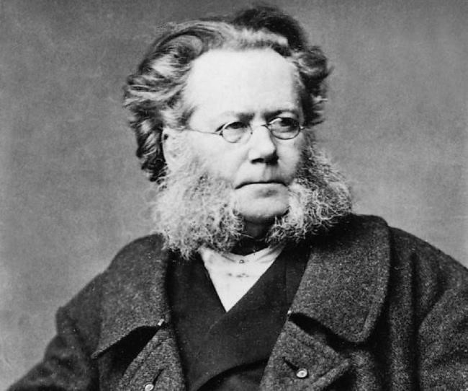Henrik Johan Ibsen, born in 1828 in Skien, Norway, was the eldest of five children after the early death of his older brother. Though Ibsen later reported that Skien was a pleasant place to grow up, his childhood was not particularly happy. He was described as an unsociable child. His sense of isolation increased at the age of sixteen when his father's business had to be sold to meet the demands of his creditors. Leaving his family at sixteen, Ibsen traveled to Grimstad, a small, isolated town, to begin his apprenticeship at an apothecary. He began to write in earnest there. Inspired by the European revolutions

***Henrik Ibsen*** of 1848, Ibsen wrote satire and elegant

poetry. At the age of twenty-one, Ibsen he

moved to the capital and turned to playwriting and journalism. He penned his first play, *Catiline* (1849). It sold only 45 copies and was rejected by every theater to which Ibsen submitted it for performance. Ibsen also spent time analyzing and criticizing modern Norwegian literature.

Still poor, Ibsen gladly accepted a contract to write for and help manage the newly constituted National Theater in Bergen in 1851. Beginning his work untrained and largely uneducated, Ibsen soon learned much from his time at the theater, producing such works as *St. John's Night* (1852). The majority of his writings from this period were based on folksongs, folklore, and history. Ibsen found his life difficult, though he did pen several plays, including *Love's Comedy* (1862), a close relation of [*A Doll's House*](http://www.gradesaver.com/a-dolls-house) (1879) in its distinction between love and marriage. Luckily, in 1864, his friends generously offered him money that they had collected, allowing him to move to Italy. He would spend the next twenty-seven years living in Italy and Germany. During this time abroad, he authored a number of successful works.

Ibsen moved to Dresden in 1868 and then to Munich in 1875. In Munich in 1879, Ibsen wrote his groundbreaking play, *A Doll's House*. He pursued his interest in realistic drama for the next decade, earning international acclaim; many of his works were published in translation and performed throughout Europe. Ibsen eventually turned to a new style of writing, abandoning his interest in realism for a series of so-called symbolic dramas. He completed his last work, [*Hedda Gabler*,](http://www.gradesaver.com/hedda-gabler) abroad in 1890.

After suffering a series of strokes, Ibsen died in 1906 at the age of seventy-eight. He was unable to write for the last five years of his life, following a stroke which also left him unable to walk. [Reportedly his last words,](http://www.gkindia.com/lastwords/alphabetical_search.asp?VAL=H) after his nurse suggested he was doing better, were, “To the contrary!”

**Did You Know?**

**Facts about *A Doll’s House***

* 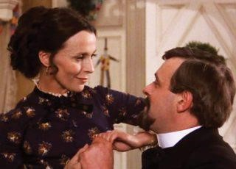There is an alternate ending of the play written by Ibsen himself in which Nora stays at the house. However, Ibsen says that this is a “barbaric act of violence” to the play and wishes theatres to not use the alternate version.

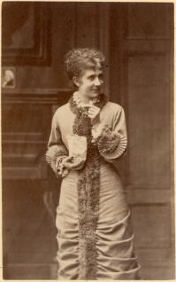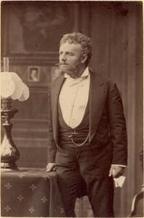

* *A Doll's House, Part 2* is a 2017 play written by Lucas Hnath. The play picks up after the end of *A Doll’s House*. It follows Nora as she returns home after fifteen years away. It examines the rules of society and gender.

* The play has been adapted for film eight different times, and even turned into a radio play.

* *Doll`s House* came out on December 4th 1879 at Gyldendalske Boghandels Forlag (F. Hegel & Søn) in Copenhagen. The first edition comprised 8 000 copies, the largest edition so far of

Ibsen`s works. The book was a sensational success,

Betty Hennings as

and the first edition was Nora and Emil

Poulsen as Torvald in sold out in less than a the original month.

production at Det Kongelige Theatre

* The first performance

of *A Doll`s House* took place at Det

Kongelige (Royal) Teater in Copenhagen A scene from the 1973 movie adaptation of *A Doll’s*

on December 21st 1879. The production *House*was sold out and a great success.

# Analysis of Major Themes

*Marriage*

The main message of A *Doll's House* seems to be that a true (ie. good) marriage is a joining of equals. The play centers on the dissolution of a marriage that doesn't meet these standards. At first the Helmers seem happy, but over the course of the play, the imbalance between them becomes more and more apparent. By the end, the marriage breaks apart due to a complete lack of understanding. Together in wedlock, Nora and Torvald are incapable of realizing who they are as individuals.

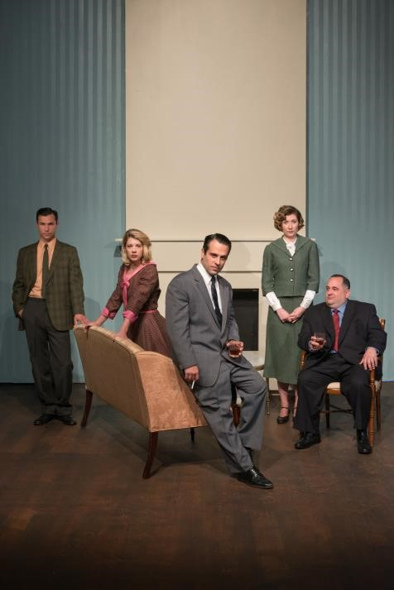

C

lassic Theatre

’

s

2017

production of

*A Doll*

*’*

*s House*

*Women and Femininity vs. Men and Masculinity* Nora of *A Doll's House* has often been painted as one of modern drama's first feminist heroines. Over the course of the play, she breaks away from the domination of her overbearing husband, Torvald. Throughout the drama there is constant talk of women, their traditional roles, and the price they pay when they break with tradition. The men of *A Doll's House* are in many ways just as trapped by traditional gender roles as the women (Torvald Helmer being the chief example). The men must be the providers. They must bear the burden of supporting the entire household. They must be the infallible kings of their respective castles. By the end of the play, these traditional ideas are truly put to the test.

*Wealth and Money*

Early on in *A Doll's House*, the characters spend a good deal of time talking about their finances. Some are on the upswing, with the promise of free-flowing cash in the future. Others are struggling to make ends meet. Either way, each character's financial status seems to be a defining feature.

*Love*

There is much talk of love in *A Doll's House*, but in the end, the Helmers discover that true love never existed between them. Throughout the play we hear of and see many different forms of love: familial, maternal, paternal, and fraternal. Romantic love even blossoms for two of the secondary characters. However, for the main characters, the Helmers, true romantic love is elusive.

# Vocabulary

* **Bewildered:** puzzled, confused
* **Calculating:** shrewd or cunning
* **Contraband:** unlawful or forbidden goods
* **Disreputable:** not considered to be respectable in character or appearance
* **Evasions:** attempts to avoid duties or questions
* **Excruciating:** the former basic monetary unit of Spain (replaced by the euro)
* **Frivolous:** silly and light-minded; not sensible
* **Grafter:** someone who takes advantage of his or her position to gain money or property dishonestly
* **Hypocrite:** a person who pretends to have virtues, moral or religious beliefs, principles, etc., that he or she does not actually possess, especially a person whose actions go against stated beliefs
* **Impulsive:** sudden and unthinking
* **Indiscreet:** unwise or not careful
* **Intolerable:** unbearable; painful; cruel
* **Proclaiming:** announcing publicly and loudly
* **Prodigal:** person who spends money wastefully
* **Properties**: whatever is considered fitting, suitable, or proper; rules of conduct or expression
* **Retribution:** punishment; revenge
* **Spendthrift:** person who spends money carelessly
* **Squandering:** spending money wastefully
* **Subordinate:** inferior; ranking under or below ➢ **Tactless:** without skill in dealing with people

# Pre-Play Activities

Reality Television

In order to encourage students to think about the choices a playwright must make when creating a play with “the look and feel of real life,” ask students to develop a new reality T.V. show. Explain to students, however, that unlike the current television offerings, these reality shows must actually attempt to appear “real.” Like the realistic dramatists of the 19th and 20th centuries, students must discard lofty or overblown theatrics and storylines in exchange for the actual and the “everyday.” Their characters must be unable to arrive easily at answers to their predicaments. Students or teams must create a proposal for their show that answers the following questions: 1. On what everyday situation or dilemma will your show focus? 2. What everyday characters will your show include? 3. What physical or philosophical problems of daily living, either social, philosophical, or psychological, will your show examine?

Individualism Vs. Social Responsibility

Walkabout Survey

To activate prior knowledge and connections to the play’s themes, have students perform a survey. Using a survey question that generates thought, provide students with a nine block (3 X 3) handout ready for responses. On the left side of the blocks going down, create blanks for three “Informers.” On the top of the blocks going left to right, create blanks for “Detail #1,” “Detail #2,” and “Detail #3.” Students then walk around and ask three different “Informers” to answer the survey question, giving three facts each. Students record their Informers’ facts in the blocks. After returning to their seats, students summarize in writing what they have learned from their classmates. Sample questions to generate a walkabout survey for A Doll’s House include:

* What is the definition of freedom?
* Does social responsibility impede the rights of the individual?
* What are society’s expectations for mothers?
* What are society’s expectations for fathers?
* Can a person contradict these expectations and still be a good mother or father?
* Do society’s expectations prevent a parent’s individual growth?
* Are society’s expectations of parents outdated in today’s world?

Marriage Debate

Play an audio recording of Ani DiFranco’s song, “Wishin’ and Hopin’.” Provide students with the lyrics, including:

Show him that you care, just for him Do the things that he likes to do.

Wear your hair just for him,‘cause You won’t get him, thinkin’ and a prayin’ Wishin’ and hopin’.

Divide the class into two groups. One group will argue that such gender roles of dominance and submission still exist in today’s society; the other will argue that today our society no longer desires such gender specific behaviors, and that true love and marriage is based on mutual respect. Ask each side to prepare supporting points, as well as predict what the opposing side will say. Challenge them to make connections to their own lives. Hold a class debate, complete with cross examinations and rebuttals.

Practical Activity

19th Century Theatrical Styles

1. Split your students into groups of three or four and give each group a scenario.

1. Allocate each group one of the theatrical styles of either Melodrama, Naturalism or Realism. Ask them to devise a short scene in that particular style to present to the rest of the class.

1. Share the scenes with the rest of the class. See if the rest of the class can guess which style they are performing in.

1. Then ask each group to perform the same scene in a different style. How does it change the scene? What are the main differences, particularly between Realism and Naturalism?

# Post-Play Activities

Now that students have seen/read the entire play, they can return to the text for a deeper understanding of its significant themes. The following topics and questions can be used for whole class and small group discussion or as essay topics.

1. *A Doll’s House* is full of references to dolls, birds, and other animals. Trace these references throughout the play while summarizing Ibsen’s ideas about gender and societal roles.

1. When Nora submits to Torvald, telling him, “Whatever you do is always right,” Torvald replies, “Now my little lark’s talking like a human being.” But later, Nora says “Before all else, I’m a human being.” Compare and contrast Torvald’s and Nora’s definitions of “human being.”

1. Ibsen infuses his play with vivid dramatic devices such as the many artificial lights, the letter hitting the mailbox, and the slamming door. How does the dramatic genre help tell the playwright’s story in a manner unparalleled by the novel form?

1. Consider the character of Torvald Helmer. Is Torvald an antagonist? A misogynist? Or could Torvald be just as much a victim of nineteenth century societal norms as Nora? Discuss.

1. Many Ibsen critics argue that *A Doll’s House* is not a feminist play, and is more about asserting self, regardless of gender. Yet Joan Templeton, in her afterword to the Signet

Classics edition of Ibsen: Four Major Plays Volume I, disagrees, asserting that “Make (Nora) a man, and the play becomes not only ludicrous, but impossible.” What do you think? Is *A Doll’s House* a play about feminism or humanism? Explain.

1. Why are there so many references to sickness and fever in *A Doll’s House*? Trace these references throughout the play. What broader concern for society might Ibsen be expressing?

1. What is the role of Dr. Rank in *A Doll’s House*? Is he simply a friend and admirer? Or is he more? Explain.

1. At the end of the play, Nora slams the door to the “doll house” and walks away. Yet she leaves Torvald with hope for “the greatest miracle.” Why did Ibsen write an ambiguous ending? Cite evidence from Nora’s and Torvald’s closing speeches to indicate what you believe to be the ultimate ending to this drama.

# Theatre Etiquette

Going to a play is a special experience, one that you will remember for a long time. Everyone in the audience has been looking forward to seeing the performance. A production team puts in

many long hours and a lot of hard work to mount a performance for an audience. If you keep in mind common courtesy for the performers as well as your fellow audience members, everyone’s theatre experience will be optimized. What follows are a few reminders for attending the theatre.

1. Plan to arrive at the theatre thirty minutes before the performance begins.

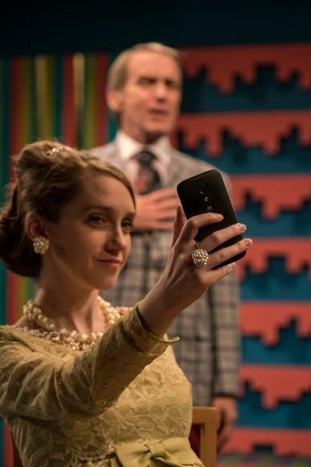

1. Gum, food, drinks, or candy are never allowed in the theatre. You may, however, bring a water bottle.

1. Please go to the bathroom before seating for the performance or at intermission.

1. TURN OFF ALL CELL PHONES or anything else that can disturb the production, actors, and audience members during the performance. It is very impolite to have your phone go off during the show.

1. Lights will dim just before a performance and then go dark. Acknowledge this by sitting quietly and calmly.

1. Do not talk or whisper during the performance. The actors on stage can hear you, which is why you can hear them so well. Laughter is of course permissible at appropriate times.

1. Keep body movements to a minimum. You can't get up and move around during the performance.
2. No taking of pictures or video recording is allowed.



1. Don't leave your seat until the cast has taken their curtain call at the end.

1. Show your appreciation by clapping. The actors love to hear applause. This shows how much you enjoyed the performance!

# Free Student Programs at The Classic Theatre

